**Artificial Intelligence and Machine Learning**

**LAB 4**

**Name: PUNEETH L**

**USN: 1BM24MC069**

**4. For a dataset, apply FP-tree algorithm, show the tree construction and identify the best rules based on support and confidence.**

Program:

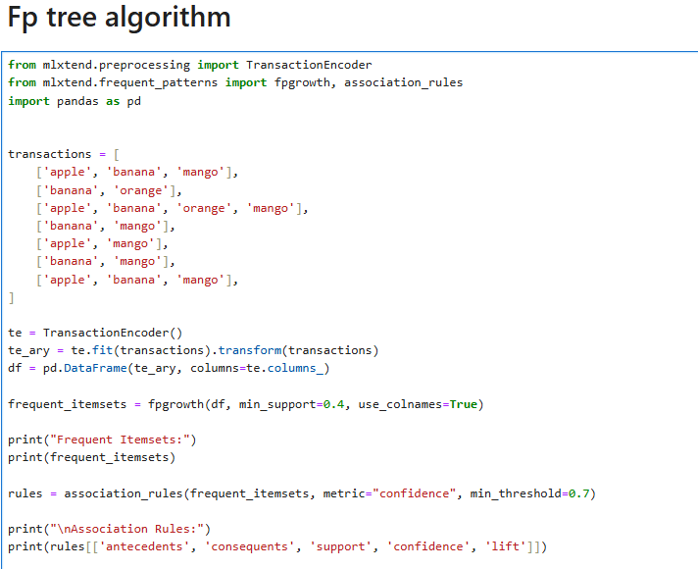

OUTPUT:

